EC2:

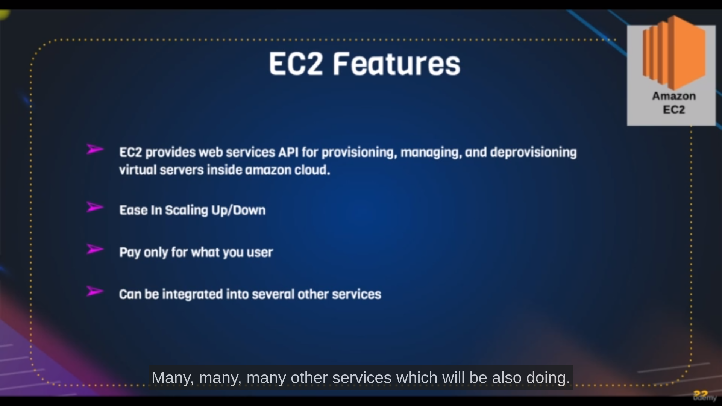ec2 is a virtual machine where we mostly use for web services

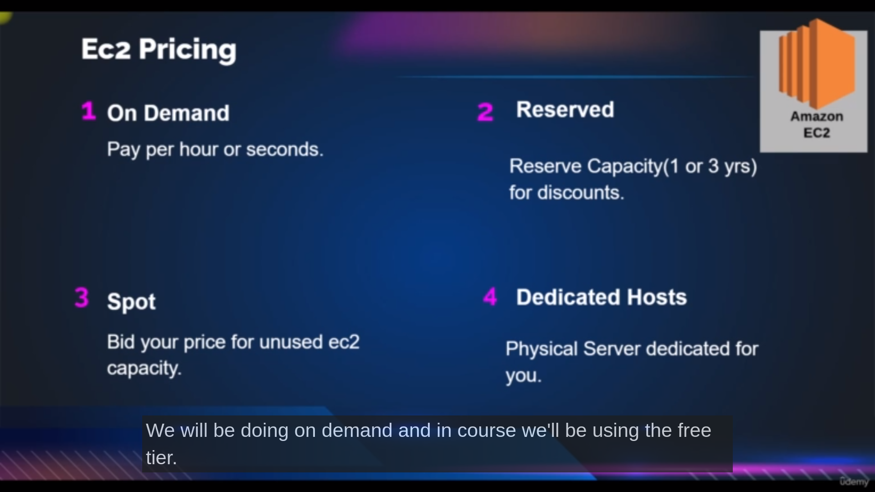we mostly use on demand ec2 instances

basic elements of ec2

Example:

amazonlinux as ami ,

t1.micro as instance type,

30gb as ROM

ec2 as tag,

ssh 22 as security group port allow anywhere,

glkey as keypair

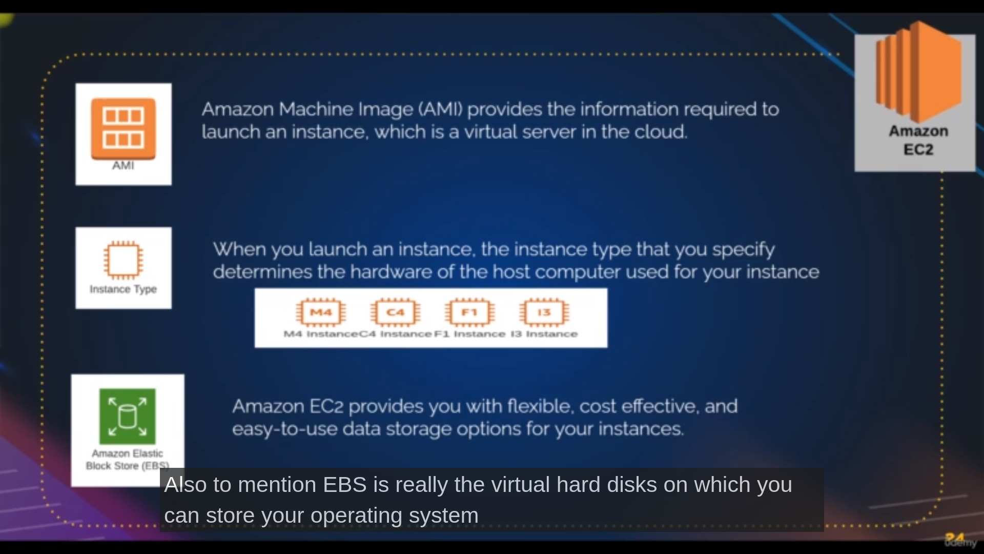

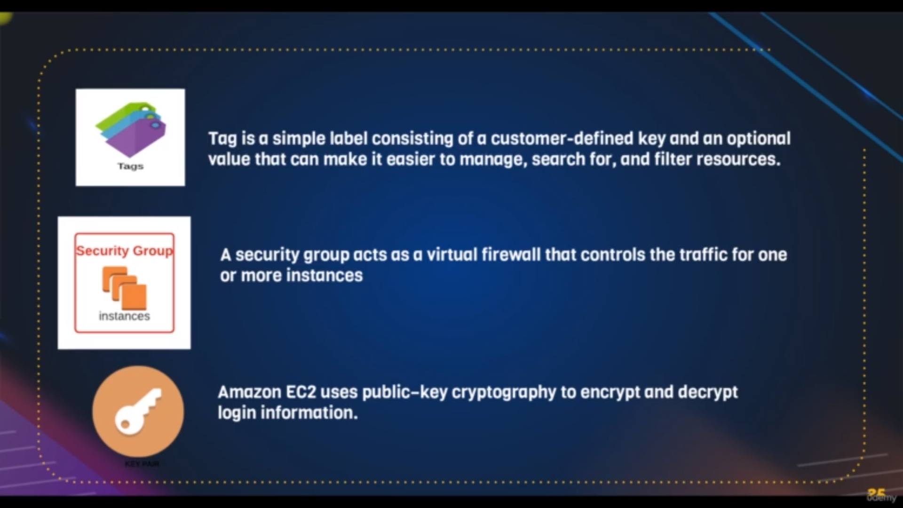this image also refers for basic elements

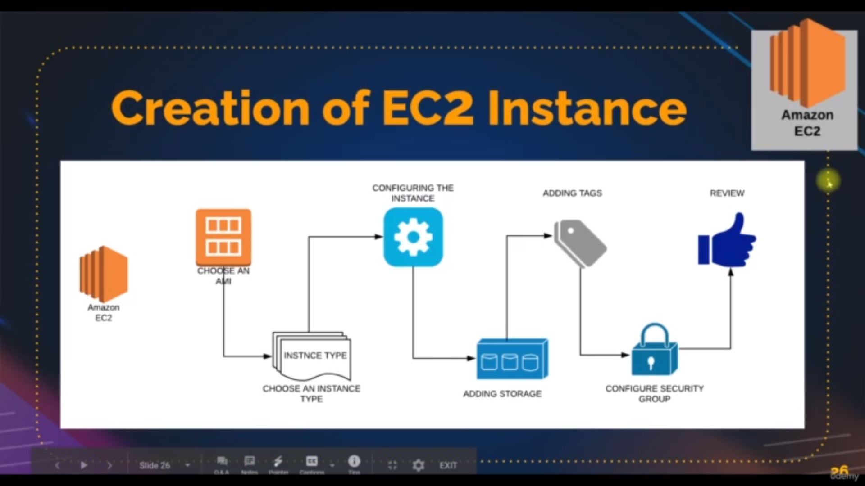flow of creating ec2 instances

Steps:prequisites: go to amazon console , search and click ec2

**step1:** click on launch instances[which direct to another pic1{a..d}]

**step2:** Enter the name of the tag in **Name and Tag section** [ it is used for filtering]

Note: we can also add multiple tags on clicking additional tags for better filtering

**step3:** choose AMI or linux machine in **Application and OS Images (Amazon Machine Image) section** [it is the actual image of linux machines]

Note: select free tier only

**step4:** select Instance type **Instance type section [** this is where you select the ram and vcpu]

**step5:** select a keypair if you have already or else click on new keypair which will create the new keypair that can use for other instances also[it is used login into vm’s]

**step6:** select existing security group or create the new security group as your convience from Network settings [it acts like firewall for machine like which port is allow and which is not allowed]

**step7:**select how much storage you needed in storage config [it is like rom (by default the rom is 8gb for amazon linux)]

Note: if we click on additional details there we find the use data where we can

write some commands so that it will exceute before we enter into the shell like

#!/bin/bash

yum install docker

systemctl start docker

systemctl enable docker

systemctl status docker

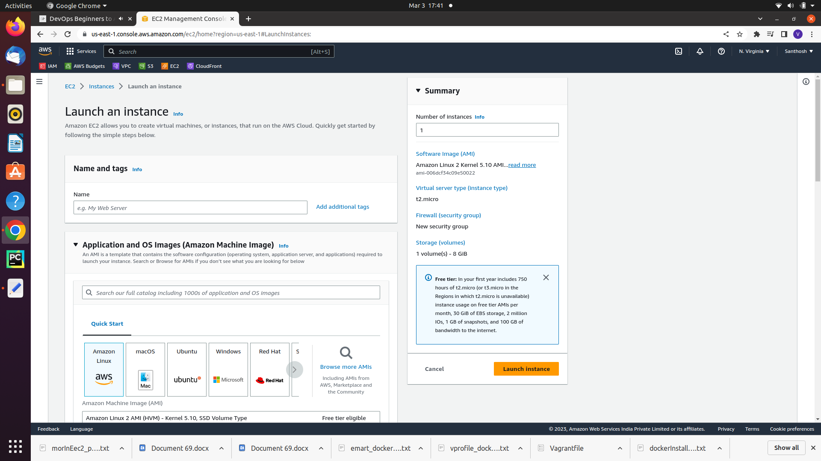pic1a

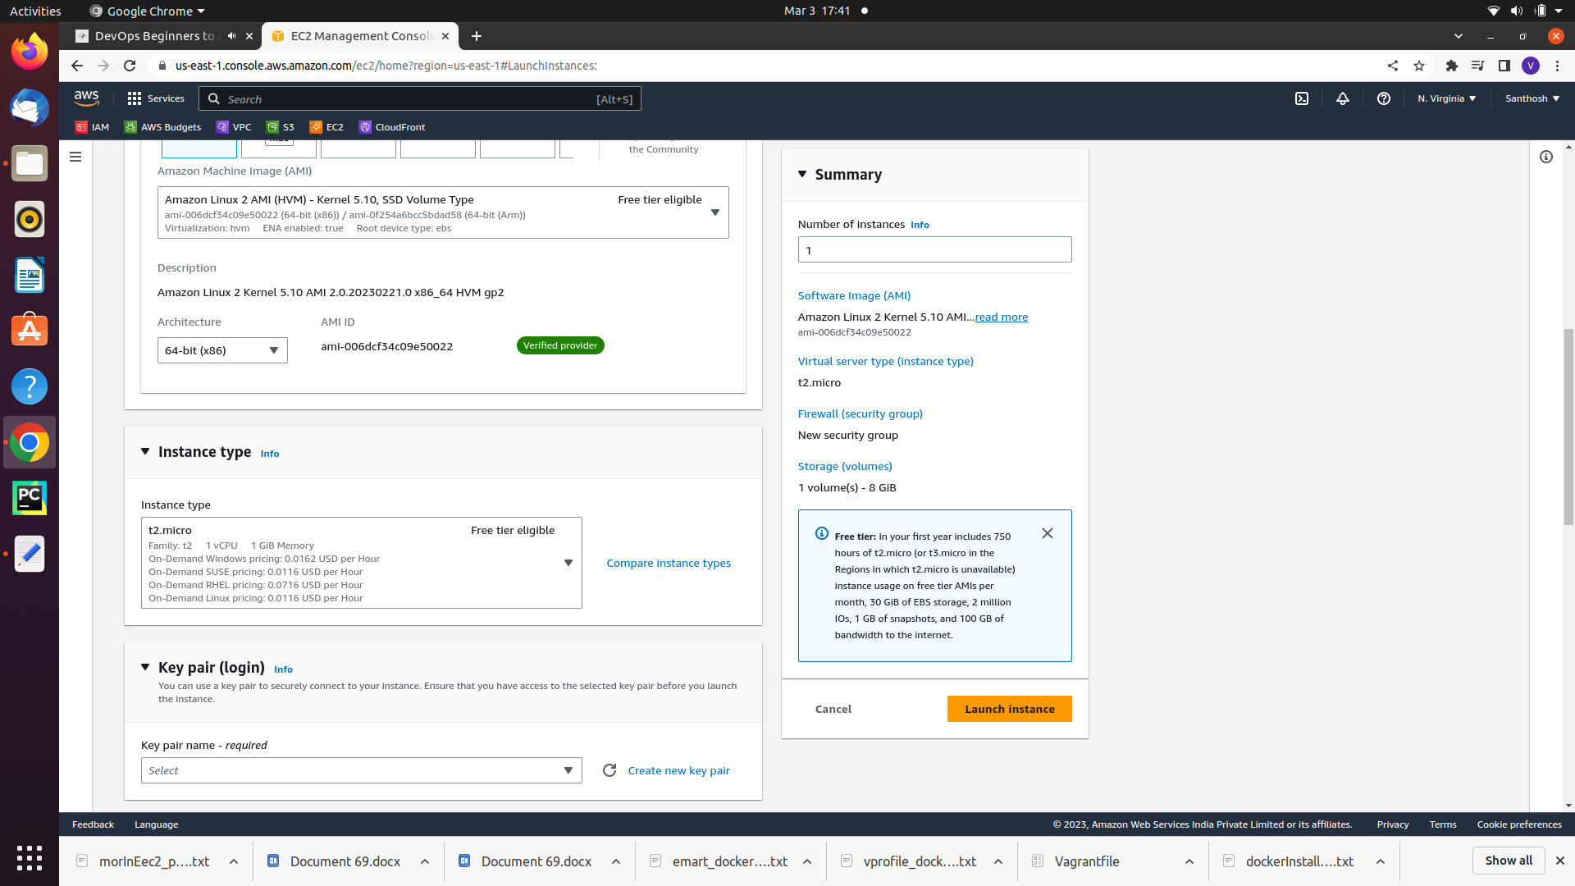pic1b

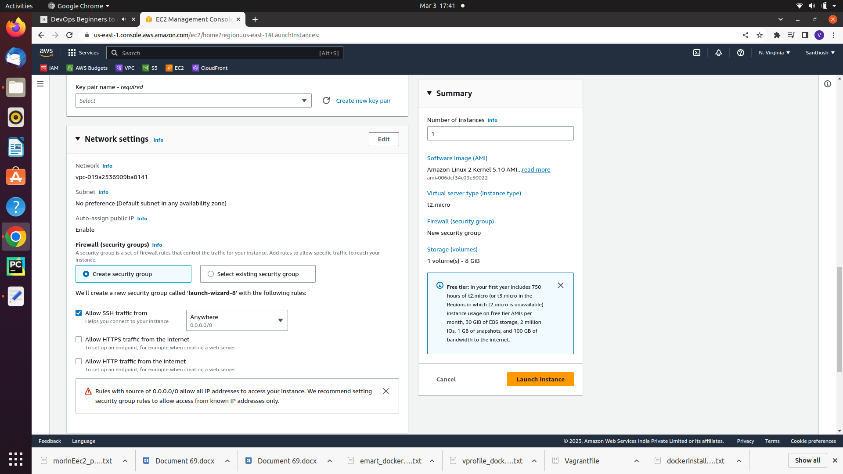pic1c

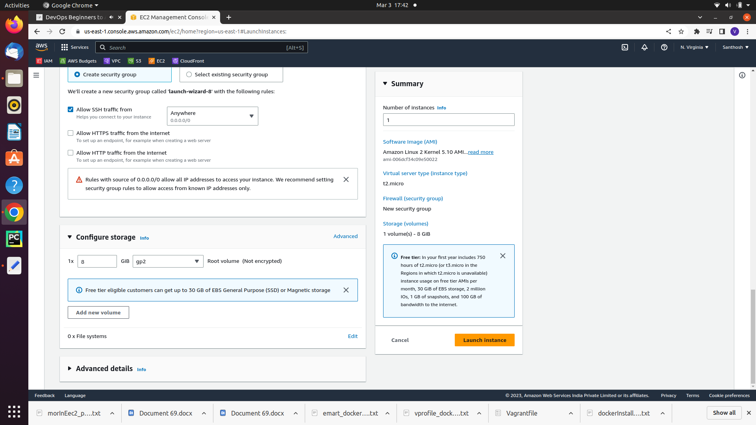p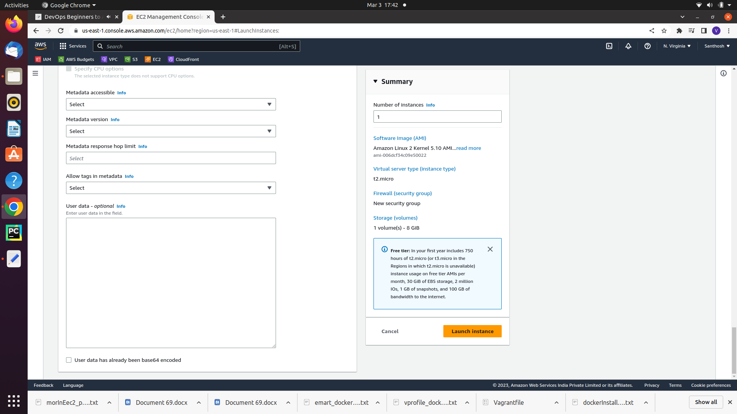ic1d

BestPractice of launcing ec2

Note: Naming Convention is mandatory

step1: requitement gathering

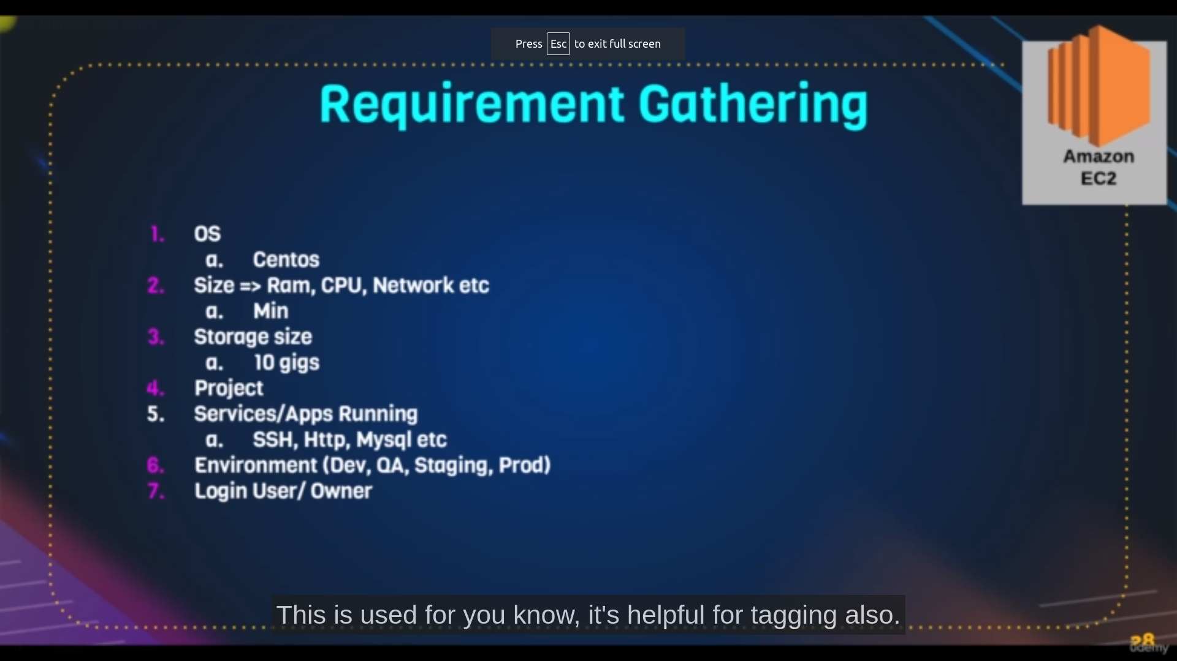requirments

Step2: create a keypair

here write keypair name with projectname-environment-region

and select pem file

step3: create security group

here write sg name

edit inbound rules a/c to req

note: the inbound rules effects on outbound rules so no need to bother about outbound rules

After this all steps are similar of above launch instance steps

Note:these step2,step3 options are there left side panel after searching for ec2

**points to remember:**

→ Elastic ip is whenever we want fix public we use ip address

→ whenever we create the instance then network interface and volume services are created automatically

→ we can also change instance type in Actions→ instance settings for this our instance should be in stop mode

→ we can also attach and detach network interface in same actions option

→ we can also add and remove security groups in same actions option

→ we can also create image from our instance in same actions option it is used whenever our instance configure more than ami instance

for example if we configure docker our instance launching new instance and installing docker on it is complex issue instead of that creating image from our instance can automatically installs docker

→ in same action option we have another moniter and trobleshoot from ther we can get system log from there we can troubleshoot our device

→ **cleanup the ec2 instance**

.click on ec2 Dashboard

makesure you have:

Zero running instances

Zero elastic ip

Zero volumes

**Actions of Ec2:**

**Create image or launch a template:**

**launch a template:**

description: template is used whenever we dont want launch instance with same details repetedly

template store all the instance details and we can launch the instance from template without enterning the repetative details

**Steps:**

**path**: on action in instances select Create image or launch a template which will store the selected instance details or on you can find it on launch template in left panel of ec2 from there you can enter new instance details

**step1**:lclick on aunch template

**step2**: enter the instance details

**step3**: click on next it will create the new template

**step4**: from template actions you can launch the instance with details what you entered in the template

**launching a ami or image:**

image is used when we want the instance with service which are installed in it by the user then we create the image from the instance which have all services and

we’ll use that for launching another instances

**Steps**:

**path**: on action in instances select Create image or launch a template

**step1**: writer the image name

**step2**: write the description

you can also do some changes as your wish

**step3**: click on create image

**step4**: after getting created image click on launching instance with ami

**step5**: enter the your instance details and launch instances